Module 6 Portfolio Milestone

**Figure 1**

*Pseudocode for Shopping Cart Part 2*

START

CLASS ItemToPurchase

ATTRIBUTES

Item_name = “none”

Item_price = 0

Item_quantity = 0

FUNC print_item_cost()

Cost = price * quantity

print (name + quantity + @ + price + = + $ + cost)

CLASS ShoppingCart

ATTRIBUTES

Customer_name = “none”

Current_date = “January 1, 2020”

Cart_items = []

FUNC add_item(self, item)

cart_items.append(item)

FUNC remove_item(self, item_name)

For item in cart:

If item_name.lower() == item[“name”]

car_items.remove(item)

// OUTPUT

Return

Else

PRINT item not found

FUNC modify_item(self, item)

Pass for now

FUNC get_num_items_in_cart(self)

Total_quantity = 0

For item in cart:

Total_quantity += quantity

Return total_quantity

FUNC get_cost_of_cart(self)

Total = 0

For item in cart:

Total += price * quantity

Return total

FUNC print_total(self)

If items in cart:

// OUTPUT

For item in cart:

item.print_item_cost()

// OUTPUT

ELSE:

PRINT cart empty

FUNC print_descriptions(self)

If items in cart:

// OUTPUT

For item in cart:

Description = item.get(“description”, DEFAULT)

Else:

PRINT cart empty

END

*Note. This pseudocode illustrates a shopping cart script in Python that allows the user to add, remove, modify, and produce output related to their cart.*

**Figure 2**

*Source Code for Shopping Cart Part 2*

***# File Name: Cline_Jason_PortfolioMilestoneW6.py***

***# Author: Jason Todd Cline***

***# Institution: Colorado State University Global***

***# Class: CSC500-1***

***# Term: 24FB***

***# Module: 6***

***# Date Created: 09/22/2024***

***# Last Modified: 09/22/2024***

**WIDTH = 40**

**class ItemToPurchase:**

**def __init__(**

**self,**

**item_name: str = "none",**

**item_price: float = 0,**

**item_quantity: int = 0,**

**) -> None:**

**"""**

**Initializes an instance of ItemToPurchase class.**

**Args:**

**item_name (str): The name of the item. Defaults to "none".**

**item_price (float): The price of the item. Defaults to 0.**

**item_quantity (int): The quantity of the item. Defaults to 0.**

**"""**

**self.item = {**

**"name": item_name,**

**"price": item_price,**

**"quantity": item_quantity,**

**}**

**def print_item_cost(self) -> None:**

**"""**

**Prints the cost of the item.**

**"""**

**cost: float = self.item["price"] * self.item["quantity"]**

**print(**

**f"{self.item['name']} {self.item['quantity']} @ ${self.item['price']:.2f} = ${cost:.2f}".center(WIDTH)**

**)**

**class ShoppingCart:**

**def __init__(**

**self,**

**customer_name: str = "none",**

**current_date: str = "January 1, 2020",**

**) -> None:**

**self.customer_name: str = customer_name**

**self.current_date: str = current_date**

**self.cart_items: list = []**

**def add_item(self, item: ItemToPurchase) -> None:**

**"""**

**Adds an item to cart_items list. Has parameter item of type ItemToPurchase. Does not return anything.**

**Args:**

**item (ItemToPurchase): The item to be added to the cart_items list.**

**"""**

**self.cart_items.append(item)**

**def remove_item(self, item_name: str) -> None:**

**"""**

**Removes item from cart_items list. Has a string (an item's name) parameter. Does not return anything.**

**If item name cannot be found, output this message: Item not found in cart. Nothing removed.**

**"""**

**for item in self.cart_items:**

**if item.item["name"].lower() == item_name.lower():**

**self.cart_items.remove(item)**

**print(f"{item_name} has been removed from the cart")**

**return**

**else:**

**print("Item not found in cart. Nothing removed.")**

**def modify_item(item: ItemToPurchase) -> None:**

**"""**

**Modifies an item's description, price, and/or quantity. Has parameter ItemToPurchase. Does not return anything.**

**If item can be found (by name) in cart, check if parameter has default values for description, price, and quantity. If not, modify item in cart.**

**If item cannot be found (by name) in cart, output this message: Item not found in cart. Nothing modified.**

**"""**

**pass**

**def get_num_items_in_cart(self) -> int:**

**"""**

**Returns quantity of all items in cart. Has no parameters.**

**"""**

**total_quantity: int = 0**

**for item in self.cart_items:**

**total_quantity += item.item["quantity"]**

**return total_quantity**

**def get_cost_of_cart(self) -> float:**

**"""**

**Determines and returns the total cost of items in cart. Has no parameters.**

**"""**

**total: int = 0**

**for item in self.cart_items:**

**total += item.item["price"] * item.item["quantity"]**

**return total**

**def print_total(self) -> None:**

**"""**

**Outputs total of objects in cart.**

**If cart is empty, output this message: SHOPPING CART IS EMPTY**

**"""**

**if self.cart_items:**

**print(f"{self.customer_name}'s Shopping Cart - {self.current_date}".center(WIDTH))**

**print(f"Number of items: {len(self.cart_items)}".center(WIDTH))**

**for item in self.cart_items:**

**item.print_item_cost()**

**print(f"Total: ${self.get_cost_of_cart():.2f}".center(WIDTH))**

**print()**

**else:**

**print(f"SHOPPING CART IS EMPTY".center(WIDTH))**

**def print_descriptions(self) -> None:**

**"""**

**Outputs each item's description.**

**"""**

**if self.cart_items:**

**print(**

**f"{self.customer_name}'s Shopping Cart - {self.current_date}".center(WIDTH)**

**)**

**print(f"Item Descriptions".center(WIDTH))**

**for item in self.cart_items:**

**description = item.item.get("description", "No description available")**

**print(f"{item.item['name']}: {description}".center(WIDTH))**

**else:**

**print(f"{'SHOPPING CART IS EMPTY'}".center(WIDTH))**

**def main() -> None:**

**"""**

**Main function to...**

**"""**

**cart: ShoppingCart = ShoppingCart("John Doe", "February 1, 2020")**

**def print_menu(cart: ShoppingCart):**

**while True:**

**print()**

**print(f"{'MENU':^{WIDTH}}")**

**print(f"{'a - Add item to cart':^{WIDTH}}")**

**print(f"{'r - Remove item from cart':^{WIDTH}}")**

**print(f"{'c - Change item quantity':^{WIDTH}}")**

**print(f"{'i - Output items\' descriptions':^{WIDTH}}")**

**print(f"{'o - Output shopping cart':^{WIDTH}}")**

**print(f"{'q - Quit':^{WIDTH}}")**

**print(f"{'Choose an option: ':^{WIDTH}}")**

**user_input = input(f"{'':^{WIDTH / 2}}")**

**match user_input:**

**case "q":**

**print(f"{'Thanks for shopping with us. Goodbye!':^{WIDTH}}")**

**return**

**case "a":**

**item_name: str = input("Enter the item name: ")**

**item_price: float = float(input("Enter item price: "))**

**item_quantity: int = int(input("Enter item quantity: "))**

**cart.add_item(ItemToPurchase(item_name, item_price, item_quantity))**

**case "r":**

**item_name = input("Enter the item name to remove: ")**

**cart.remove_item(item_name)**

**case "c":**

**item_name = input("Enter the item name to modify: ")**

**cart.modify_item(item_name)**

**case "i":**

**print()**

**print(f"{'OUTPUT ITEMS\' DESCRIPTIONS':^{WIDTH}}")**

**cart.print_descriptions()**

**case "o":**

**print()**

**print(f"{'OUTPUT SHOPPING CART':^{WIDTH}}")**

**cart.print_total()**

**case _:**

**print(f"{'Invalid input. Please choose a valid option.':^{WIDTH}}")**

**print_menu(cart)**

**print("\n")**

***# Hard-coded for assignment as proof of concept without user input:***

***# Create items with hardcoded descriptions as placeholders***

**item1 = ItemToPurchase("Nike Romaleos", 189.00, 2)**

**item1.item['description'] = "Volt color, Weightlifting shoes" *# Placeholder description for now***

**item2 = ItemToPurchase("Chocolate Chips", 3.00, 5)**

**item2.item['description'] = "Semi-sweet" *# Placeholder description for now***

**item3 = ItemToPurchase("Powerbeats 2 Headphones", 128.00, 1)**

**item3.item['description'] = "Bluetooth headphones" *# Placeholder description for now***

***# Add items to shopping cart***

**shopping_cart = ShoppingCart(customer_name = "John Doe", current_date = "February 1, 2020")**

**shopping_cart.add_item(item1)**

**shopping_cart.add_item(item2)**

**shopping_cart.add_item(item3)**

***# Print item descriptions as proof of concept***

**shopping_cart.print_descriptions()**

**if __name__ == "__main__":**

**main()**

*Note. Source code that illustrates a shopping cart script in Python that allows the user to add, remove, modify, and produce output related to their cart. Some methods are incomplete at the moment besides adding and displaying item totals and descriptions.*

**Figure 3**

*Execution and Testing for Shopping Cart Part 2*

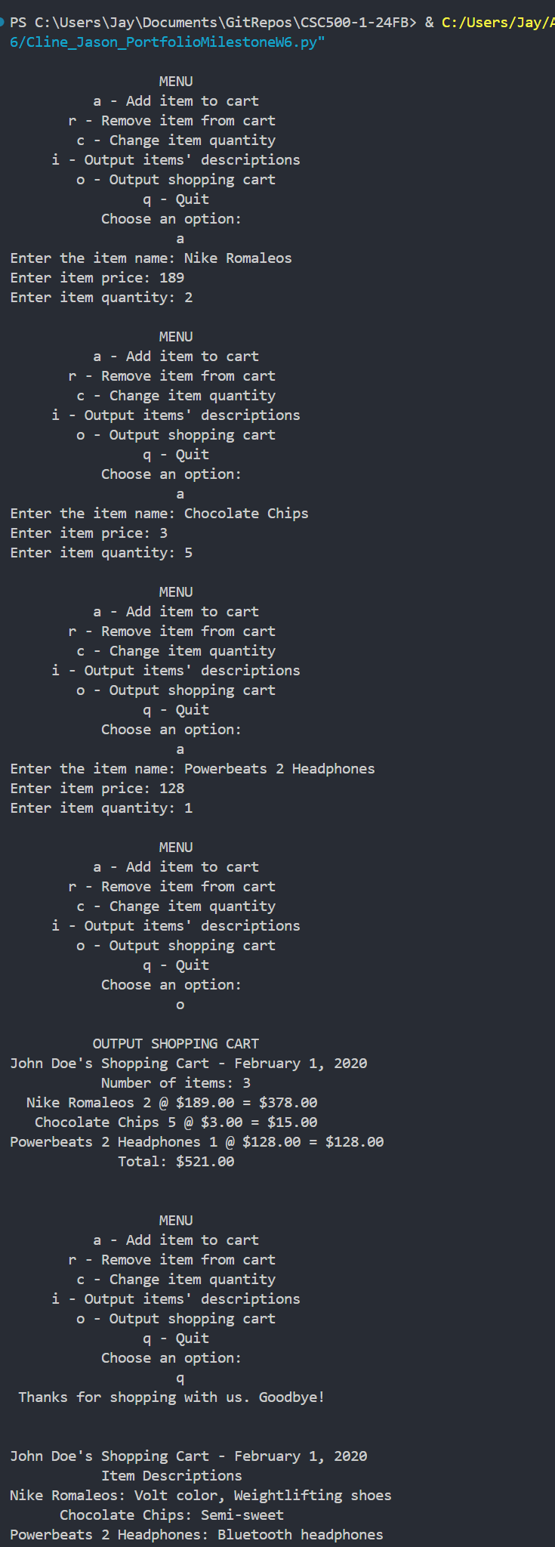

**

*Note. Execution and testing of a shopping cart in Python that allows the user to add, remove, change, and output descriptions and total. Testing shows adding items, displaying totals, and displaying descriptions. Descriptions are hard-coded as part of the second milestone as proof of concept.*

References

Cline, J. T. [Jay4rmTheBay]. (2024). *CSC500-1-24FB* [Source code]. GitHub.<https://github.com/Jay4rmTheBay/CSC500-1-24FB>